# Ideation Phase Empathize&Discover

|  |  |
| --- | --- |
| Date | 3 july 2025 |
| Team ID | LTVIP2025TMID50858 |
| Project Name | ToyCraft Tales: Tableau's Vision into Toy Manufacturer Data |
| Maximum Marks | 4 Marks |

* **What is an Empathy Map?**

An **empathy map** is a collaborative visual tool used to understand a user's thoughts, behaviors, emotions, and needs. It helps teams build a deep, shared understanding of their users and view the problem through their lens. Typically, it is divided into four or more quadrants: **Says, Thinks, Does, and Feels**, sometimes also including **Sees** and **Hears**. This

method is a crucial part of the **ideation phase** in design thinking, helping to create solutions that are truly user-centered.

# Who Is the Toycrafter?

Meet our user: a design-savvy dreamer in Toyland, exploring the best builds, brands, and play features. They care deeply about *playtime range*, *charging up fun*, *design sparkle*, and *price-performance magic*.

They use Toycraft Dashboards to compare toy features, spot trends in play styles, and decide which delightful gadget or character to add to their shelf.

* **Key Toycrafter Insights**: The Toycrafter…
  + 🗯️ *Says things like:* “Which figure has the coolest moves?” “Is this fun worth the coins?” “How quickly can I power it up?”
  + 💡 *Thinks about:* durability, imagination value, and whether it outplays other classics.
  + ❤️ *Feels:* eco-curious, budget-wise, and thrilled by innovation.
  + 🅧 *Does:* compares toys online, checks accessory sets, reads kid & collector reviews.

# 🎨 Why It Matters in the World of Whimsy:

Knowing how Toycrafters think and play helps us build dashboards that speak their language—full of sparkle, stats, and story. With this empathy, Toycraft visualizations don’t just inform—they enchant, support decisions, and bring

imagination to life, one playful chart at a time.

* 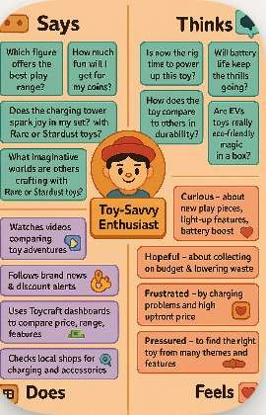

# Conclusion:

By stepping into the shoes of our Toycraft explorer, we gain playful clarity on what truly matters— whether it's comparing the *fun range*, *charging thrill level*, or *brand sparkle*. With that

understanding, we build Tableau dashboards that feel like intuitive toyboxes—simple, vivid, and exciting to open.

These dashboards spotlight the most delightful trends: which models are making waves, how fast they charge their fun reserves, and what toys offer the best play-for-price magic.

In the end, this empathy-driven design helps Toycrafters navigate their choices with ease—turning data into discovery and comparison into joy.